THERE WILL BE AN EXTRA ORDINARY MEETING OF
THWING AND OCTON PARISH COUNCIL
ON MONDAY 29th APRIL 2019 AT 7.00 PM AT THWING CHURCH ROOMS
THIS IS AN OPEN MEETING AND MEMBERS OF THE PRESS AND PUBLIC ARE WELCOME TO ATTEND
Matters for Discussion are itemised below.
AGENDA
1) Apologies

2) Declaration of Pecuniary or Non-Pecuniary Interest
3) To consider and agree comments to planning application 19/01122/PLF change of use of land for the erection of shower/toilet block, siting of 3 camping pods and associated parking and landscaping. Applicant Mr & Mrs D Jibson. Location: Land South East of 2 Old Octon Farm Cottages, Octon Grange Lane, Y025 3EB

Signed
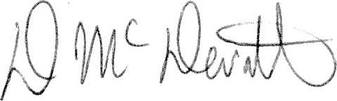

D McDermott
Chairman 23.04.2019

